Add this to cloud or mapping git along with bashrc copy
sudo udevadm trigger --subsystem-match=video4linux

AortaScope core dependencies:
- Pytorch for FUNSR
- FUNSR (make sure to also backup)
- Tensorflow for DeepLumen
- Model weights for DeepLumen (all you need)
- ROS Noetic
- rospy
- OpenCV2 Python
- Open3D
- Numpy
- Tkinter
- Yaml to load parameter yamls and calibration yamls
- Subprocess
- Voxblox tsdf integrator (optional)
- CUDA
- CUDNN
- Custom vacancy ESDF python bindings (optional)
- Caktin
- GCC
- EM tracker ROS workspace
- USB CAM ROS workspace
- Rosserial node with arduino code embedded
- Slicer environment
- Segmentation helpers
- Reconstruction helpers
- Deformation helpers
- Gating (optional)
- matplotlib
- Scipy spline fitting
- time, math, copy, glob, random, os, sys
- testmodule (IVUSProcPybind) for SCEM segmentation
- not comprehensive
- Vacancy package

Setting up a new computer with IVUS mapping system and robot:

- install ubuntu 20.04 or purchase computer with Ubuntu 20.04 preinstalled – link
- if dualbooting alongside windows, preferably a thinkpad or something with tested ubuntu compatibility – link
- Ideally pick a computer that doesn’t have intel rapid storage technology (RST)
- In windows shrink partition to desired size, turn off bitlocker in windows, turn off secure boot during boot phase (F12 or similar), boot from usb where ubuntu iso image has been installed with rufus, choose all default settings ideally if not greyed out (no extra download options)
- Upgrade to python 3.9.5 and ensure which python and which python3 return the 3.9.5 same for python –version and python3 --version
- install ROS Noetic – link – VNAV – pip install curl and omauthlib
- Install Git and setup SSH keys for pushing and pulling easily
- build VNAV workspace for open-cv3 needed for ivus segmentation and google protobuf

Real-time ROS functions:
- To get the frame grabber working:
  - pull “usb_workspace” and catkin build
  - install usb_cam ros package first – sudo apt-install ros-noetic-usb-cam
  - sudo apt-get install libv4l-dev
  - source devel/setup.sh (and add it to your .bash_rc if you don’t want to run this every startup)
  - in usb_cam config, edit the yaml file such that we pick the right camera device (the frame grabber) – use ls /dev to do this and determine which one changes – it will likely be dev/videoX or something – make sure to catkin build again when you change this
  - also change the dev/videoX to the same in the launch file inside launch folder
  - for troubleshooting the frame grabber install sudo apt install v4l-utils, and then run v4l2-ctl –list-formats-ext
  - v4l2-ctl –list-devices

- To get the EM tracker working on a linux system
  - clone the “EM_tracker” workspace on from either roche group / tdillonmit github
  - sudo apt-get install libusb-dev
  - catkin clean, catkin build in EM_tracker/EM_tracker – TRY CATKIN_MAKE instead
  - source devel/setup.bash in the same directory (and add it to your .bash_rc if you don’t want to run this every startup)
  - lsusb find the device ID (unplug and replug, it should be something like Cypress semiconductors), and add the relevant line to lib-usb rules 99 file inside src add something like : SUBSYSTEM=="usb", ENV{DEVTYPE}=="usb_device", ATTRS{idVendor}=="04b4", ATTRS{idProduct}=="1005", MODE="0666"
  - sudo cp /home/tdillon/EM_tracker/EM_tracker/src/ascension_ros/99-libusb.rules /lib/udev/rules.d/99-libusb.rules
  - sudo chmod 644 /lib/udev/rules.d/99-libusb.rules
  - sudo udevadm control –reload-rules
  - sudo udevadm trigger
  - replug the USB port of the EM tracker
  - check if demo.launch works

- pip install rospy
- make sure you’re using the correct version of python in all codes – python3.9 – you can check this by importing sys module and printing python version in the code
- To set up the image gating – download rosserial from roswiki – see arduino tutorials and do the first one
- then download the rosserial_gating_prototype code on the roche lab github, open in arduino
- upload the sketch to the nano every (note you may need to install rosserial from within the arduino IDE as well as nano every interface – see manage libraries under tools)
- this creates a ros publisher for the ecg signal that you can subscribe to

Healthy aortic mapping:
- Install scem_ivus_segmentation python bindings → “test module”
- Install voxblox_pybind – exactly as instructed at link here, run “sudo apt-get install -y protobuf-compiler libprotobuf-dev” before doing a make install, sudo apt install python3.9-dev, may need vcpkg to get pybind11, and change the setup file.py (will automatically install pybind11)
- pip install open3d
- “mapping” workspace
- catkin init, catkin build, source devel/setup.bash
- you need to install GSL 1.15 from GNU to make the scem_pybind inside the build folder, you also need to run sudo apt install libsuitesparse-dev
- you may need add “export CMAKE_PREFIX_PATH=/home/tdillon/.local/lib/python3.9/site-packages/pybind11:$CMAKE_PREFIX_PATH” to bashrc
- importing opencv2 should work if you have opencv3 catkin installed on your machine

creating symbolic link for the frame grabber (not sure if there are other frame grabber references in here) – specific to av.io frame grabber bought on ebay
sudo nano /etc/udev/rules.d/99-usb-video.rules
SUBSYSTEM=="video4linux", ATTRS{idVendor}=="2b77", ATTRS{idProduct}=="3601", SYMLINK+="video-grabber"
sudo udevadm control --reload-rules
sudo udevadm trigger –subsystem-match=video4linux

To prevent computer from crashing and overheating on a laptop
You should install thinkfan to ensure fans engage at lower temperatures
sudo nano /etc/thinkfan.conf
even if the gpu is within temperature / power limits, on a laptop this can still overheat the cpu
you can either turn off intel cpu turbo boost, reduce clock speeds by installing cpupower (from 5Ghz to 4Ghz), or limit PL2 (turbo boost power limit) on cpu – if the screen is freezing up, it might be the CPU
sudo nano /etc/systemd/system/cpufreq.service

[Unit]
Description=Set CPU max frequency
After=multi-user.target

[Service]
ExecStart=/usr/bin/cpupower frequency-set -u 4.0GHz

[Install]
WantedBy=multi-user.target

sudo systemctl enable cpufreq.service
sudo systemctl start cpufreq.service

Registration:
- plant_registration
- pc-skeletor

Dissection mapping:
- install conda → environment
- download and install NVIDIA drivers for your gpu – check with NVIDIA website
- Download and install relevant cuda toolkit
- Verify both with “nvcc –version” and “nvidia-smi”
- add cudnn to path
- pip -m install tensorflow[and-cuda]
- Download weights from online training script
- vacancy for esdf voxel carving – note that esdf_pybind pulls from the original vacancy folder

minimal setup for dissection mapping:

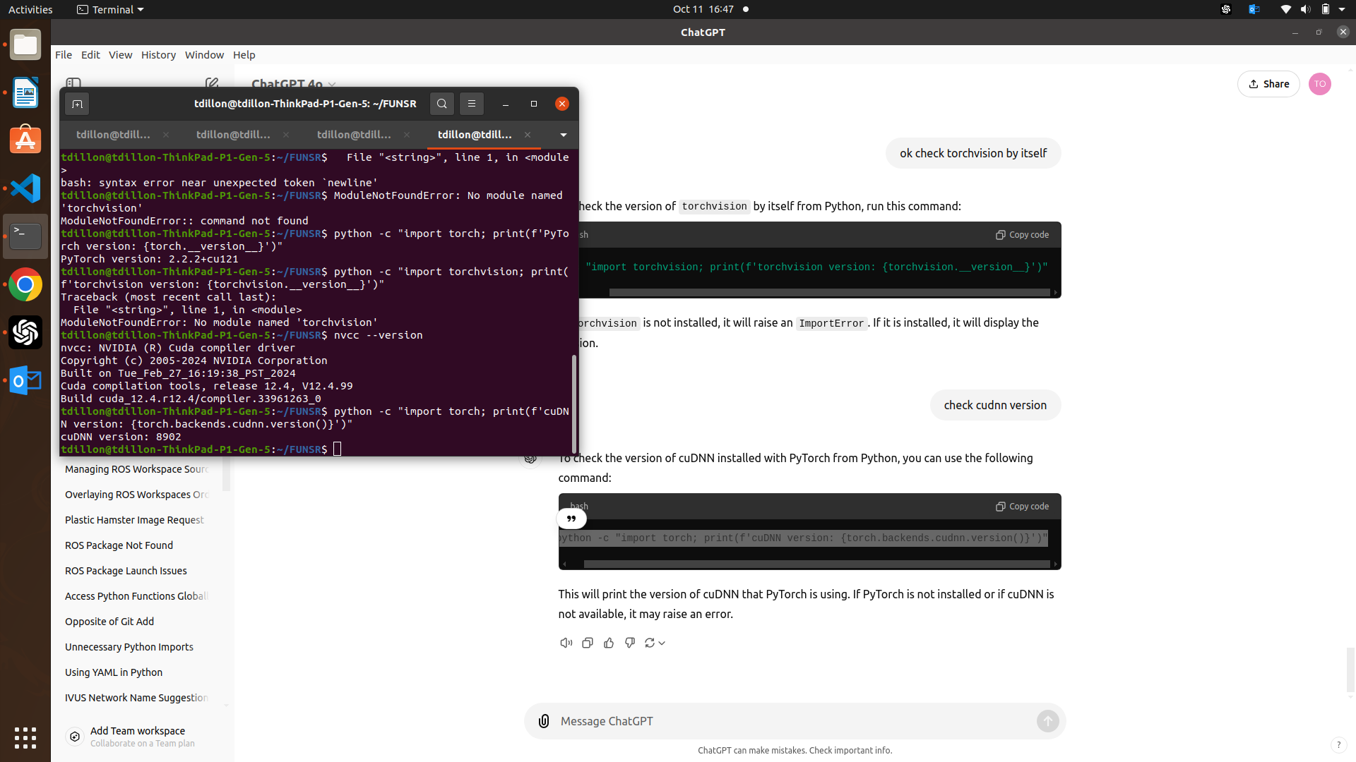
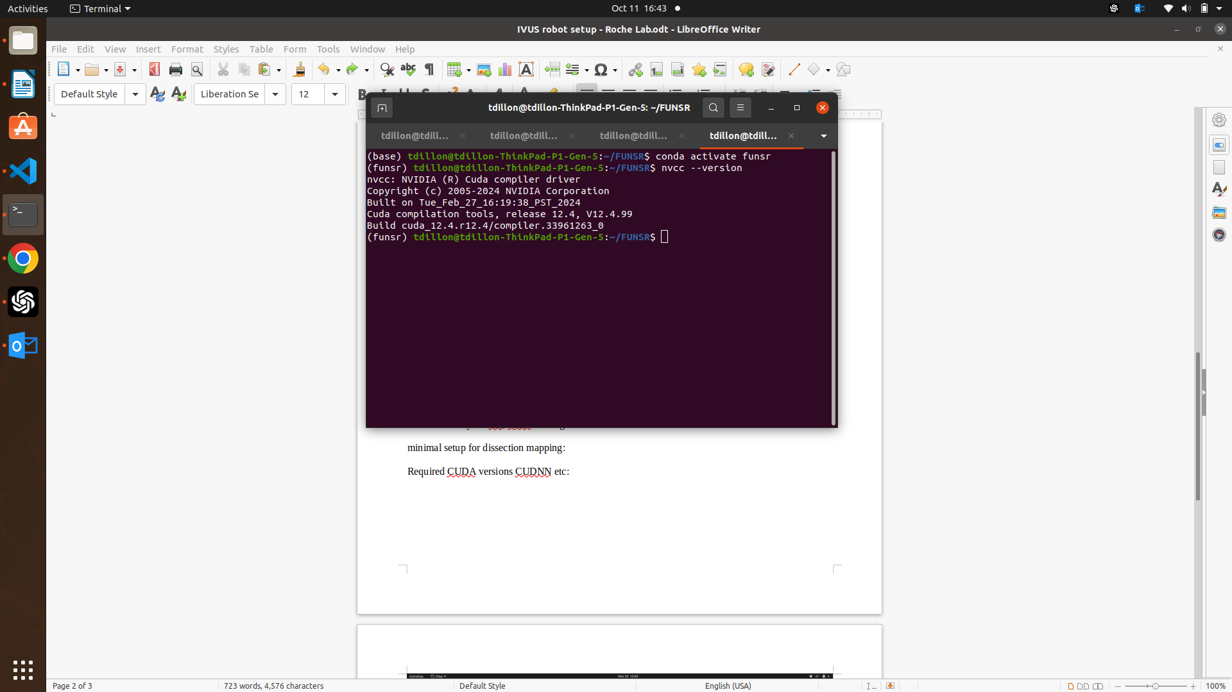
Required CUDA versions CUDNN etc:

